EOI Template Outline (+/- 1,500-2,500 words per EoI) – Due date CoB September 19

Please submit EoIs to Masud Rana (MASUD.RANA@cgiar.org)

Section 0 – Title and contact Information
- Title of the proposed solution track:

Scaling Inclusive Rice Transplanting Mechanization Services in Bangladesh
- Title of the AoW2 Flagship that the solution track aligns with:
Grand Challenge 2: Deliver Inputs and Services at Scale through Inclusive Market Systems
Flagship 2.2: Catalyzing Mechanization and Postharvest Services through Agribusiness Growth
- Lead Scientist(s) / Contact Person(s) / Center(s)
Owen Calvert, Project leader, CIMMYT

- Emails of the Lead Scientist(s) / Contact Person(s) / Center(s)
Owen Calvert, CIMMYT o.calvert@cgiar.org
- Key CGIAR Center Partners (in the case of multi-Center EoIs)
CIMMYT (Innovation bundle from the bilateral projects)
- Technical link to other Science Programs – name the corresponding Science Programs by name
This innovation has been developed as a part of CIMMYT’s bilateral projects but has no direct link with any of the CGIAR’s Science Program.

Section 1 – Innovation Package, Value Proposition & Alignment
Purpose: To establish what the innovation is, who the customers and end-users are, why it matters, and how it connects to S4I’s Flagships and Grand Challenges.
- The problem to be solved:
Rice is the backbone of Bangladesh’s food system, grown on 11.4–11.8 million hectares producing 36–37 million tons annually. The sector faces bottlenecks such as labor shortages, high planting costs, suboptimal practices, and declining profitability, making timely planting difficult. Rice Transplanters (RTs) can reduce costs by 25–30% and improve yields, but adoption is very low. The Government of Bangladesh aimed to deploy 3,000 RTs by 2025, while the projected demand to achieve full mechanized transplanting by 2030 is 49,172. However, DAE records only 425 RTs provided through subsidies, with 1-3% effectively operational. Major barriers include limited training in seedling raising and machine use, weak after-sales services, scarce spare parts, and poor access to finance. This EOI proposes scaling an inclusive Machinery Service Provision (MSP) model to deliver timely, affordable RT services to farmers, particularly in underserved regions including Dinajpur, Mymensingh and many others.

- Your scaling ambition: Describe the ambition of your proposed Scaling Solution track. Which of the KPIs do you believe you will contribute most towards, and at what level of quantitative and qualitative impact? (~150 words)

Our ambition is to scale 1,000 rice transplanters (RT) nationwide by 2028, enabling mechanized transplanting services across 50,000–55,000 hectares annually. This expansion will lower production costs for farmers by 25–30% and directly benefit more than 150,000 farm households creating a net saving of USD 2.75 million in a year with scaling investment. This will create jobs, for youth as RT operators and women as seedling entrepreneurs. By catalyzing a sustainable market for mechanization services, the track will contribute to S4I KPIs including: (i) increased number of farmers adopting mechanized transplanting (ii) expanded land area under improved, climate-smart practices; (iii) creation of inclusive rural jobs and enterprises; and (iv) enhanced institutional uptake of mechanization financing and policies. This scaling track directly contributes to Grand Challenge 2: Deliver Inputs and Services at Scale through Inclusive Market Systems and aligns with donor priorities around food security, livelihoods, and private sector driven growth.
- Innovation & Value Proposition – Describe the innovation or bundle or package (maturity, novelty, suitability for scaling) and the benefits it delivers to institutional partners/customers and end-users (e.g., productivity, resilience, nutrition, risk reduction, institutional capacity). Can include linkages to other science programs that will collaborate and work on the innovation/bundle/package (~150 words)

This innovation, adopted under CIMMYT’s bilateral mechanization project, is an integrated Machinery Service Provision (MSP) model that combines RT services with a complementary rice seedling production business. Rather than farmers investing in machines individually, trained MSPs deliver RT services at scale, supported by private firms, MFIs, and public extension systems. To ensure a reliable supply of quality seedlings, women seedling entrepreneurs invest in seed sowing machines that automatically sow the seed in trays, enabling efficient and standardized seedling production. The value proposition includes: (i) productivity gains from timely, uniform transplanting; (ii) 25–30% savings in labor costs; (iii) inclusivity through women-led seedling enterprises; (iv) sustainability through private service networks ensuring utilization, spare parts, repair, and finance access; and (v) climate adaptation via timely planting that mitigates flood and drought risks. This MSP model is mature, scalable, and aligned with national mechanization strategies requiring donor catalytic investment to unlock private-sector sustainability at scale.

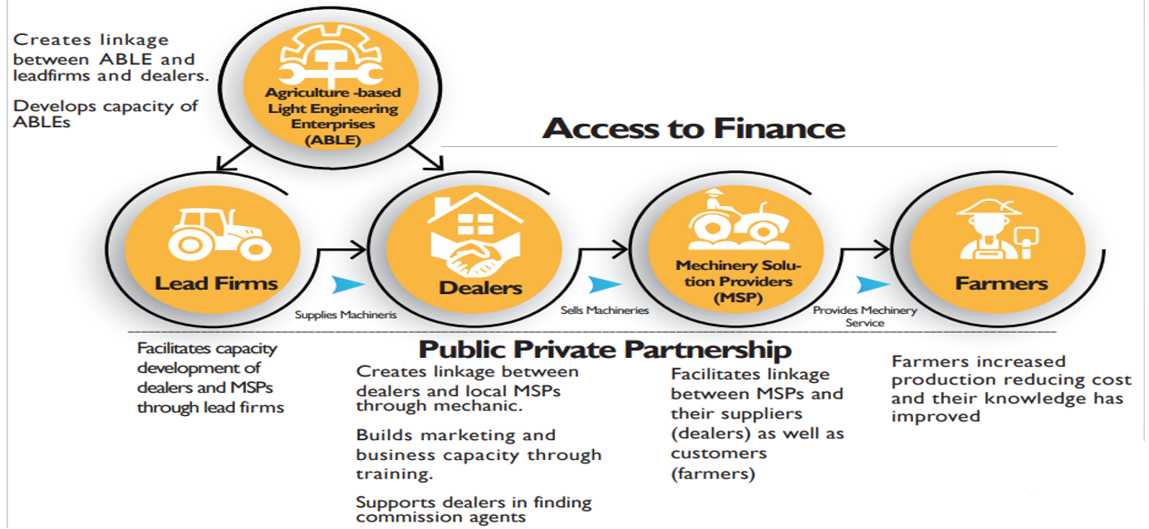
Mechanized rice transplanting through the RT MSP model creates a win–win system, where service providers earn sustainable profits and farmers achieve lower costs and improved productivity as below. Instead of several people needed for manual transplantation, mechanized transplantation needs only two people.

Perspective | Key Metrics | Figures (USD)
MSP (Service Provider) | Machine Price | 4,000 – 5,000
 | Annual Income  (50 days operation annually) | 2,500 – 3,000
 | Annual Expense | 800 – 900
 | Annual Profit | 1,500 – 2,000
 | Net Profit per Hectare | 50 – 55
 | ROI | 35 – 40%
Farmer | Manual Transplanting Cost | 200 – 205 / ha
 | Machine Transplanting Cost | 140 – 145 / ha
 | Savings of Machine over Manual (USD) | 55 - 60 / ha
 | Cost Saving (%) / ha | 25 – 30%
 | Additional Benefits | Timely planting → higher yield-climate adaptation

- Customers & Alignment – Identify the main institutional customers (ministries, donor programs, agribusinesses, lenders) and end-users (farmers, SMEs, cooperatives). Show how the track aligns to an AoW2 Flagship and Grand Challenge. (~100 words)
Institutional customers include the Ministry of Agriculture (MOA), Department of Agricultural Extension (DAE), banks, MFIs, and agribusinesses such as ACI Motors Ltd., The Metal Agritech, Abedin Equipment Limited, GSM, Uttaron Enginering, local manufacturers and dealers. End-users are smallholder farmers, youth and women RT operators, seedling entrepreneurs. The track aligns with Flagship 2.2 under Grand Challenge 2, as it catalyzes mechanization services through inclusive market systems and agribusiness growth. It also links with national agricultural mechanization strategies, donor programs on rural livelihoods, and CGIAR initiatives in mechanization and climate adaptation.

- Evidence of Impact – Provide citations and evidence of both effectiveness (impact) and scalability in practice (uptake beyond pilots, adoption drivers). (~150 words)

Evidence from Bangladesh shows RTs reduce planting costs by 20–30% and increase yields by ensuring uniform, timely transplanting (Aravindakshan et al., 2024a). Demonstrations supported by CSISA-MEA, and DAE established farmer willingness to adopt RT services when machines are accessible through service providers (Aravindakshan et al., 2024a, 2024b). DAE subsidy programs have validated government support, while private firms have expressed strong demand for partnerships and expansion (Aravindakshan et al., 2024b). Evidence further shows mechanized rice transplanting reduces production costs, improves timeliness, and increases farmer willingness to adopt when services are accessible . Report confirms increasing farmer adoption of mechanized services and identified key barriers such as financing and after-sales support that need donor and private-sector investment CSISA’s results confirmed steady scaling of MSP-led mechanization, stronger dealer networks, and evidence of government alignment through subsidy programs. CIMMYT’s bilateral mechanization project has been linked to CGIAR’s S4I, with reported scaling impact contributing to global scaling learning S4I

Section 2 – Scaling Pathway, Sustainability, Partnerships & Risks
Purpose: To assess whether there is a credible pathway for the innovation to scale through public, private, or PPP delivery models — supported by sustainability plans, partner demand and commitments, financial leverage, and risk mitigation.
- Scaling Pathway & Sustainability – Describe how the innovation bundle and/or package will scale (public, private, PPP). Explain how the solution will remain viable at scale (revenues, public financing, PPP, IFI/donor support), with milestones or cost-recovery targets. (~250 words)

The scaling pathway is a PPP model combining:
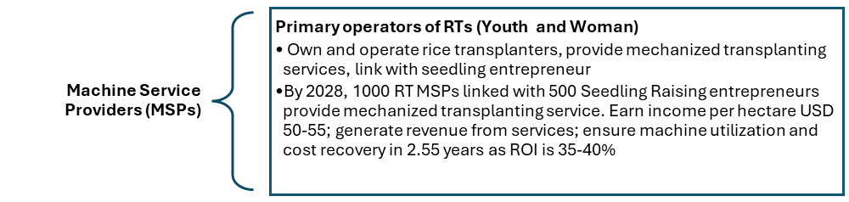

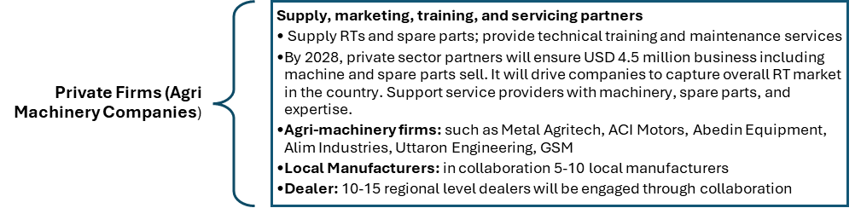

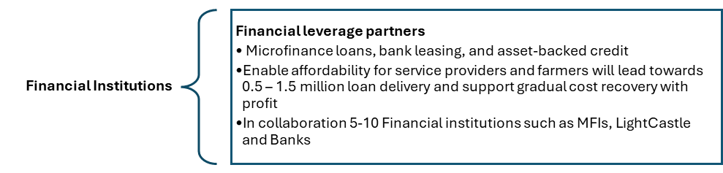
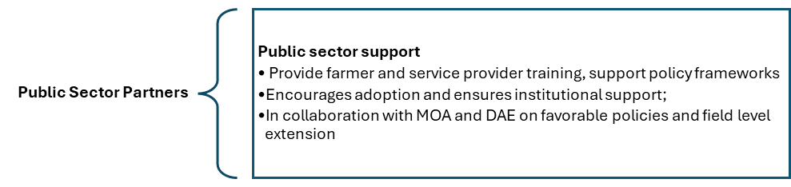
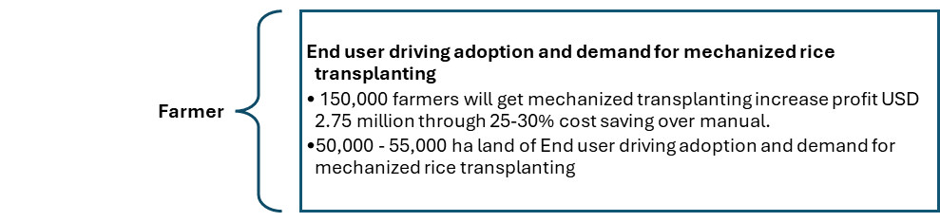

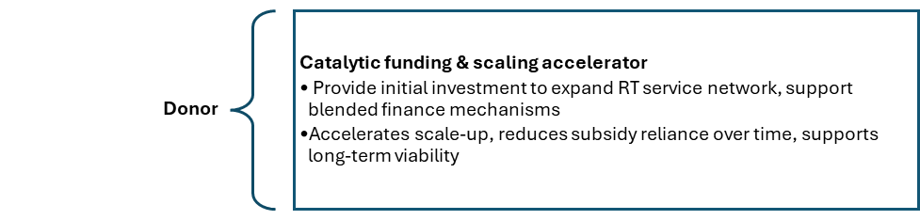

- Partnerships & Leverage – Identify internal CGIAR champions and external partners that have a stake in championing the innovation bundle or package, provide evidence of demand (surveys, requests for collaboration, alignment with policies or strategies) and commitment (MOUs, LOIs, budget allocations from partners, or other evidence of demand), and specify major non-CGIAR programs or investments this track can leverage (budgets, partners, polices, programs, etc). (~300 words)

Internal Champions (CGIAR)
CIMMYT: Technical and Delivery Lead

- Md. Kafil Uddin (Market Systems Development Coordinator) is the focal point for private and public sector involvement and strengthening market systems.
- Bharathi Parupalli (Training Manager) is the training lead, experienced in designing responsible scaling inclusive training programs that empower farmers, youth, and women to adopt innovative mechanization services at scale.
- Hera Lal Nath (Hub Manager) is instrumental in establishing networks with the stakeholders- government, private sector, service providers and farmers. He has demonstrated this innovation bundle for the past five years.
- Md. Fazlul Karim (Machinery Development Officer) is an experienced agriculture engineer who is key for technology and spare parts development

External Champions and delivery partners:
Private Sector Partners:
- Agri-machinery companies: 3-5 agri-machinery companies such as The Metal Agritech, Abedin Equipment, ACI Motors, Uttaron and GSM will be champion of the for machinery supply, marketing, and after-sales services of rice transplanter and seed Sower machines.
- Local Manufacturing firms: 5-10 local manufacturing firms (SMEs) such as SMR Agro, Al Madina, RK Metal, Shahin Engineering, and Janata Engineering will champion the production of local spare parts.
- Dealers: 10-15 district level dealers will be champion the marketing of rice transplanter, seed Sower machines and spare parts.
Machine Service Providers (MSPs): RT MSPs including women and youth will lead and champion the service provision model while women seedling entrepreneurs will scale the business across these districts.
Financial Institutions: Banks, innovative financing organization such as light castle, and Micro-finance institutes such as Gram Unnayan Karma(GUK), Society Development Committee(SDC), and VPKA foundation are providing credit for purchasing rice transplanter and seed sowing machines. This model will be scaled up to new financial institutions.
Public sector partners: The public-sector linkages with DAE and the Ministry of Agriculture will be leveraged to access technical support, training platforms, and farmer outreach mechanisms, and policy making to replicate and expand the scaling solution in new geographic areas.
Farmers: Farmers drive the demand and adoption of mechanized rice transplanting.
CGIAR Centers: CIMMYT (lead on scaling mechanization), IRRI will help with technical advice on seedling systems, with synergies across climate and policy research programs.

Evidence of Demand:
- Letters of Intent and MOUs: Signed MOU with the Bangladesh Agriculture Research Council (BARC) and the Department of Agriculture Extension (DAE). Received ‘letters of intent to collaborate’ from the private sector partners who intend to invest a matching amount to CGIAR’s funding for scaling up the innovation bundle.
- IPSR and Scaling Readiness Training and Workshops: Over 40 CIMMYT staff have been trained on IPSR. CIMMYT in Bangladesh is working on IPSR training to 60 national partner staff.
- Fit with the priorities of national government and donors: Bangladesh government has a national mechanization program aiming at scaling up mechanized cultivation across different crops and this EOI aligns with those priorities.
- Risks & Bottlenecks – Identify specific risks (financial, political, operational, social, or others) and bottlenecks (policy, institutions, finance, technology) in the specific context and place that could hinder scaling. Describe potential mitigation strategies to address these risks and bottlenecks. (~250 words)
Potential risks and bottlenecks include:
Financial risks: Farmers’ limited ability to pay upfront. Mitigation: blended finance combining subsidies, loans, and leasing.
Operational risks: Poor machine servicing networks. Mitigation: strengthening after-sales service capacity with local firms.
Policy risks: Policies on import taxes might increase the prices in the country creating an uncertainty among buyers. Mitigation: policy engagement and advocacy for performance-based incentive tied to machine utilization.
Social risks: Gender barriers to participation in mechanization. Mitigation: promoting women-led enterprises in seedling and post-harvest services, providing gender training, and developing women-friendly financing models.
Climate risks: Floods or weather shocks affecting planting. Mitigation: mechanization enables timely planting and adoption of short-duration rice varieties to reduce exposure.
Through proactive risk mitigation and partnership support, the MSP model provides a robust and adaptable pathway for nationwide scaling of RT services.

Section 3 – Responsible Scaling Trajectory & Achievable Scaling Target
Purpose: To define what can realistically be achieved with S4I support in the next 2–3 years — including achievable reach, milestones, resources, activities, and safeguards for responsible scaling.
- Readiness & Responsible Scaling – Provide evidence of scaling readiness (IPSR or similar evidence). Describe actions for ensuring that scaling will be inclusive (extending to women, youth, marginalized groups) and environmentally sustainable. (~150 words)
Scaling Readiness assessments place the RT MSP model at 9 level. It has been tested in pilot and early scaling contexts, with strong evidence of adoption drivers and bottlenecks. Responsible scaling is embedded through inclusive design. Women will lead seedling services, youth and women will operate and manage RTs, and smallholders will gain affordable access through service providers. Environmental safeguards include reduced methane emissions from timely planting, and improved resource efficiency. The track applies gender-responsive tools to integrate gender equity, and ensures that marginalized groups in target regions are included in service delivery and finance schemes.

- Achievable target, Resources & Activities – Define what can realistically be achieved in 2–3 years starting 2026 forward with S4I support and current/planned partnerships. Outline the key resources (staff, institutional, financial, technical) and activities (e.g., training, policy engagement, distribution) required. (~250 words)
By 2028, with S4I support, the track will achieve: 1,000 RT MSPs and 500 woman led seedling entrepreneurs nationwide, reaching 150,000 farm households and covering 50,000–55,000 hectares. Growth will progress from 200 MSPs/100 entrepreneurs in 2026, 300/150 in 2027, and 500/300 in 2028. This pathway is anchored by 3–5 agri-machinery companies, 5–10 local fabricators, 10–15 dealers, and 5–10 FIs (MFIs, banks, LightCastle). Government partners (DAE, policy bodies) will drive awareness, training, and enabling policies, ensuring farmer affordability, MSP profitability, and national mechanization sustainability.

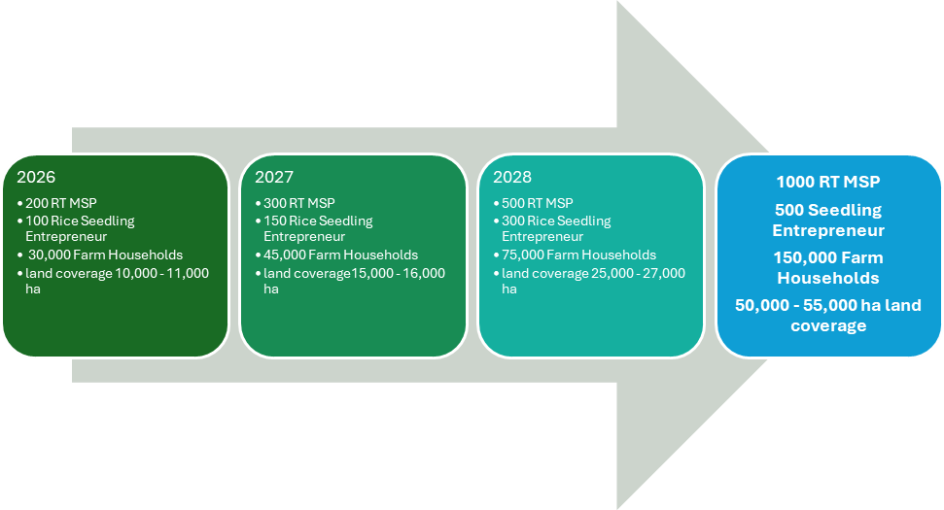

Key activities include: scaling farmer field demonstrations, digital awareness campaigns, operator training programs, incubation of women-led enterprises, strengthening of the machine supply chain, development of blended finance schemes, and policy engagement for subsidy reform and mechanization strategy implementation. Resources required include $500k annually for coordination, training, awareness, and partnership mobilization, leveraged by private sector investment. The project builds on existing CGIAR and donor-funded initiatives, creating synergies for greater impact.
Staffing: This scaling solution track will engage two field operations managers, two agriculture engineers, two capacity sharing experts, a market systems development expert, a communications expert, and a Monitoring, Evaluation, Learning, and Impact Assessment (MELIA) officer.

- Timeline, Milestones & Monitoring – Provide an estimate of annual milestones for 2026–2028 (users reached, partnerships formed, policies adopted). Explain how progress will be monitored, lessons captured, and adaptations made. (~200 words)
Target Year | Milestone | Outcome | Indicator
2026 | - 200 RT MSP  - 100 Rice Seedling Entrepreneur  - 30,000 Farm Households  - land coverage 10,000 - 11,000 ha | Baseline; RT and Seeding entrepreneurs trained and service provision, PSE investment co-investment  Financing mainstreamed | # of farmers benefited  # of MSPs and seedling entrepreneurs  # machines sold by private sector and co-investment  # Credit amount availed
2027 | - 300 RT MSP  - 150 Rice Seedling Entrepreneur  - 45,000 Farm Households  - land coverage15,000 - 16,000 ha | RT and Seeding entrepreneurs trained and service provision, PSE investment co-investment  Financing mainstreamed | # of farmers benefited  # of MSPs and seedling entrepreneurs  # machines sold by private sector and co-investment  # Credit amount availed
2028 | - 500 RT MSP  - 300 Rice Seedling Entrepreneur  - 75,000 Farm Households  - land coverage 25,000 - 27,000 ha | Endline; evidence of adoption informs national policy and donor pipelines. | # of farmers benefited  # of MSPs and seedling entrepreneurs  # machines sold by private sector and co-investment  # Credit amount availed

Monitoring will use S4I-aligned KPIs: Adoption numbers, jobs created, financing leveraged, women and youth participation, emission reductions. Adaptive learning will feed into annual PORB cycles, ensuring iterative improvement. The MELIA team will ensure data quality through the application of standardized, verifiable tools and will systematically track KPI progress on a quarterly basis. To complement routine monitoring, an annual sample survey will be conducted at the end of Q4 to generate impact-level evidence for analysis and reporting. All MELIA tools will be GESI-responsive, incorporating disaggregation by sex, age, and ethnicity to ensure inclusivity and equity in measurement. The team will align with and apply all S4I guidelines and data quality assurance processes, while also leveraging evidence for continuous learning, reflection, and adaptive management.

Optional Annexes
- IPSR Innovation Profile (if available)
- Scaling Readiness assessment results
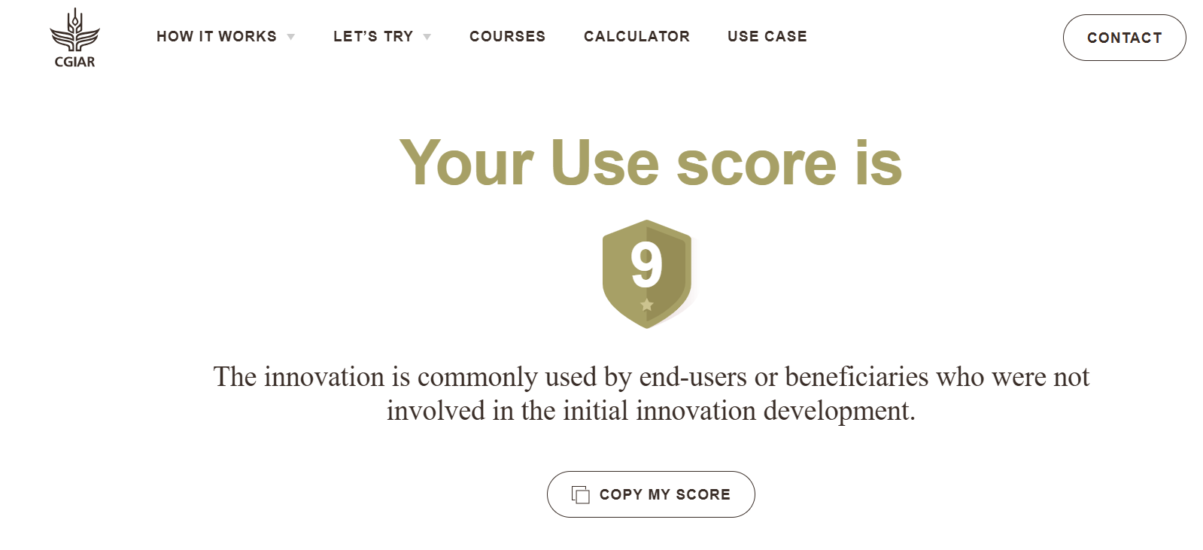
- Scaling Scan results (if available)
- Prior project reports
https://csisa.org/wp-content/uploads/sites/2/2024/11/CSISA-MEA-Yr5-An-Rpt-29-Oct-24_web.pdf
https://csisa.org/wp-content/uploads/sites/2/2023/02/CSISA-MEA-Annual-Progress-Report-September-2022-1.pdf
https://csisa.org/wp-content/uploads/sites/2/2021/11/211028-FtF-CSISA-MEA-FY2021-AR-USAID-BD_web.pdf
https://csisa.org/wp-content/uploads/sites/2/2023/05/230426-CSISA-MEA-Semi-Annual-Report.pdf
- Media or other evidence of prior scaling work that can be accelerated
https://bangladeshpost.net/posts/rice-transplanter-reduces-labour-crisis-in-jibannagar-77491
https://www.newagebd.net/article/128789/dae-introduces-rice-seedling-transplanter-machine-in-phulbari?utm_source=chatgpt.com
https://bangladeshpost.net/posts/dae-launches-rice-seedling-transplanter-machine-in-nageshwari-78800
https://www.dhakatribune.com/business/200877/rice-transplanter-brings-hope-for-tangail-farmers?utm_source=chatgpt.com
https://www.tbsnews.net/agriculture/using-rice-transplanter-can-increase-harvest-10-15-brri-1116731?utm_source=chatgpt.com
- MELIA studies, impact assessments, reports, publications
- Partner commitments (MOUs, LOIs, letters of support)

Monitoring and evaluation will use MELIA frameworks to track hectares covered, number of farmers reached, jobs created, women and youth participation, finance leveraged, and environmental outcomes. Annual reviews and learning workshops will capture lessons and adapt strategies.

Annex 1: Resources & Tools to Support EOI Preparation
Teams preparing EOIs are encouraged to draw on the following core resources. These tools are directly aligned with the S4I operational criteria and will help ensure EOIs are evidence-based and robust:

Core Resources
- Scaling Scan
  - Practical tool to assess strengths and weaknesses across 10 “scaling ingredients.”
  - Helps identify gaps in demand, finance, governance, partnerships, or capacities.
  - Resource: Scaling Scan
- Innovation Packages and Scaling Readiness (IPSR)
  - CGIAR’s framework for assessing innovation maturity (readiness) and use, and for identifying bottlenecks and strategies for scaling.
  - Can provide a Scaling Readiness Level (SRL) and bottleneck map useful for Criterion 3.
  - Resource: CGIAR IPSR Overview
- Business Model Canvas (BMC-lite)
  - Adapted version of the BMC for development contexts.
  - Useful for thinking through value proposition, partnerships, cost structures, and sustainability.
  - Resource: Business Model Canvas: Templates and examples available via AoW2 co-leads.
- Responsible Scaling Guidance
  - GenderUp: A tool to integrate gender and inclusion into scaling design, helping identify trade-offs and opportunities for equitable, responsible scaling
  - Helps applicants strengthen Criterion 3 (Responsible Scaling safeguards).
- MELIA (Monitoring, Evaluation, Learning, Impact Assessment) Evidence
  - Past MELIA studies, adoption surveys, or bilateral project evaluations are valuable sources of impact evidence.
  - Resource: Contact MELIA focal points within your Center for relevant reports and datasets.

95% land preparation, pesticide spraying mechanised: DAE - The Business Post
Mechanized Cultivation Increases Labour Efficiency | Bangladesh Rice Journal
https://csisa.org/wp-content/uploads/sites/2/2024/11/CSISA-MEA-Yr5-An-Rpt-29-Oct-24_web.pdf
https://csisa.org/emam-hossens-influential-path-to-progress-in-agriculture-through-engaging-youth/
Aravindakshan, S., Parupalli, B., Uddin, K., Hoque, M. A., Islam, S., Calvert, O., & Krupnik, T. J. (2024). Economics, demand and challenges of mechanization: A data note on mechanization service provision in Bangladesh. Research Note 49. TAFSSA. https://hdl.handle.net/10883/35396
https://csisa.org/stories-of-agricultural-mechanization-in-bangladesh/
https://csisa.org/stories-of-agricultural-mechanization-in-bangladesh/
https://csisa.org/wp-content/uploads/sites/2/2024/11/CSISA-MEA-Yr5-An-Rpt-29-Oct-24_web.pdf
https://csisa.org/wp-content/uploads/sites/2/2023/02/CSISA-MEA-Annual-Progress-Report-September-2022-1.pdf
https://csisa.org/wp-content/uploads/sites/2/2023/05/230426-CSISA-MEA-Semi-Annual-Report.pdf
https://www.linkedin.com/posts/cgiar-scaling_stories-of-agricultural-mechanization-in-activity-7366756827226652673-fbUg

